**Monay Wallet User Manual**

**Get Started with Monay Wallet**

Monay Wallet offers fast electronic payments with just one click. Sign up to get started.

**Create a Monay Wallet Account**

You need to sign up for a Monay wallet account to allow one party to make electronic transactions with another party bartering digital currency units for goods and services

1. Download from Google Play or Apple Store
2. Sign up
3. Verification
4. Complete KYC (Know Your Customer) Information

* **Download from Google Play or Apple Store**

You can download the Monay wallet application according to the version required

1. Download Monay wallet for Android from Google Play
2. Download Monay wallet for iOS from Apple Store

* **Signup**

To create a Monay wallet account, go to the application and Click Signup

*<<screenshot of Home>>*

You can sign up for the Monay wallet as following roles

1. **Primary Users: If you are an Individual user sign up as a primary user. As a primary user, you can** 
   * **The primary wallet holder will set a limit to the secondary wallet**
   * **Primary wallet holders can also self-fund or receive or send funds for free.**
   * The primary wallet holder can transfer the amount to the secondary wallet holder
   * The primary wallet holder will have a history of transactions performed by the associated secondary wallet holder.
   * Primary wallet holders can choose an option to let secondary wallet holders perform
   * **One primary user can have multiple secondary users.**
2. **Secondary Users: If you are an Employee, Servant, Relative, or Worker of the primary user sign up as a secondary user. As a secondary user you can** 
   * **Primary users or Merchant controls the secondary users.**
   * **All the transactions made by the secondary wallet holder are known to the primary wallet holder.**
   * **A secondary user can go through the full KYC or KYC lite which determines their spending limits.**
   * **All the transactions made by the secondary user will be visible from the primary user’s wallet.**
3. **Merchant: If you want to register as a Business, Corporation, Retailer, Shopkeeper, Online Store, or any Merchant** 
   * Merchants must go through full KYC
   * Merchants can send payment requests to Primary or Secondary user wallet holders in with bill information as well as in the form of a bill with a link to the PDF version of the bill.

* **Verification**

Once the user selects the role, a mobile number is required to verify the account. Monay wallet has been launched in US and India so the phone country code can be selected accordingly. A six-digit One-time password (OTP) will be sent to the provided mobile number.

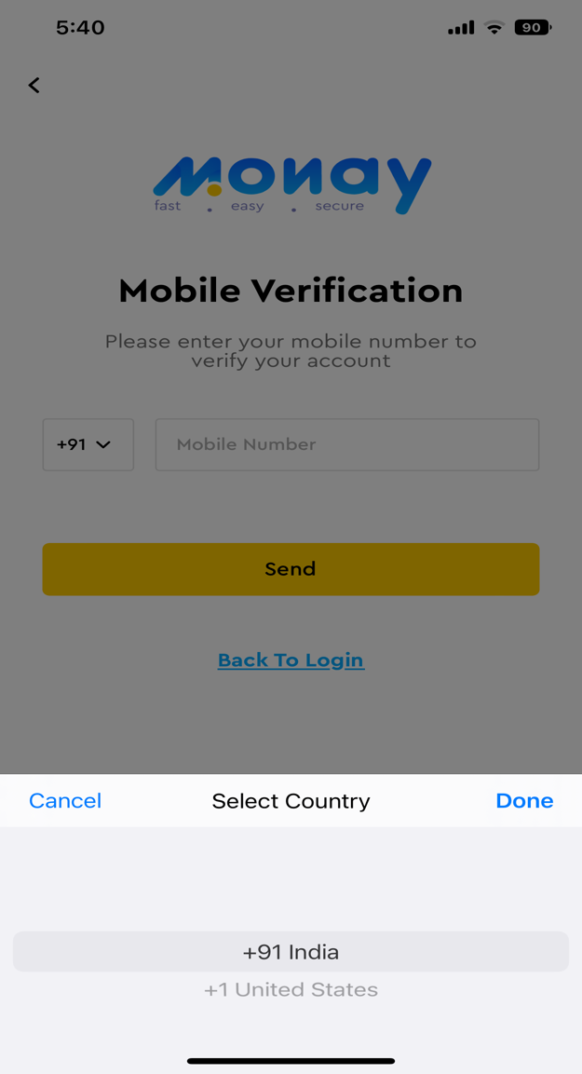

**Sign in**

You can sign in with your registered mobile number or email address.

1. Enter your registered mobile number or email address
2. Enter correct password
3. Click on Login button

Select relevant country code first to enter phone number.

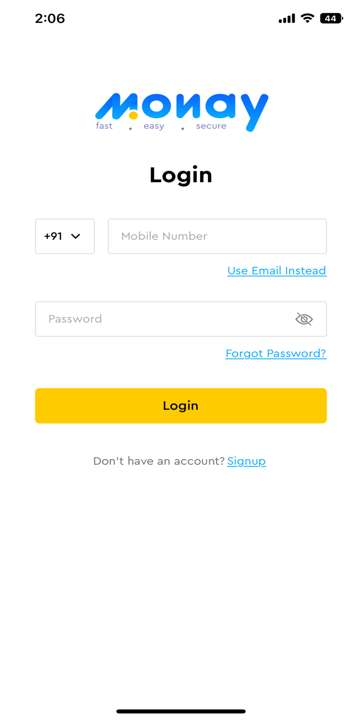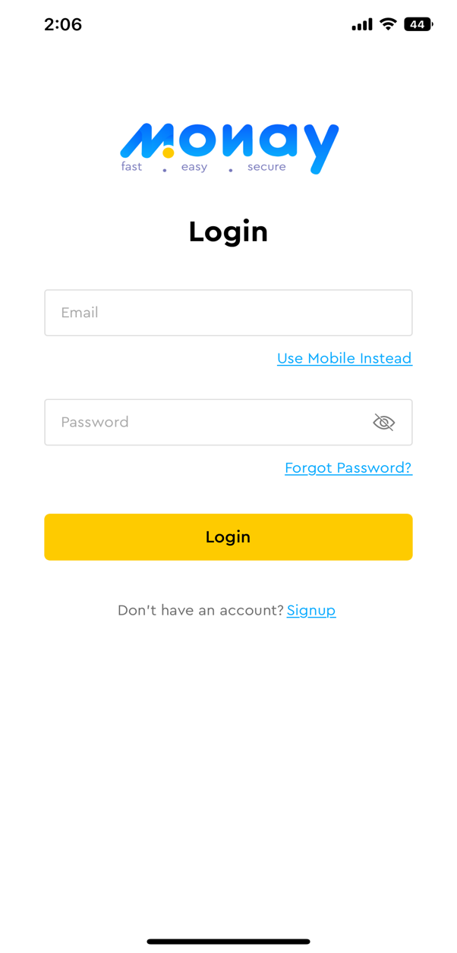

* **Dashboard**

**Dashboard**

Monay wallet dashboard will be equipped with a wide range of features such as analytics and real-time statistics charts that help the user gain valuable insight. The user can navigate to complete different features

You must [Sign in](https://qagps.monay.com/portal/sign-in) to access your Monay wallet Dashboard

## Dashboard

The Monay GPS (Global Payment System) Dashboard provides the facility of the following:

* + Available balance
  + Detail of recent payment requests
  + Detail of transactions

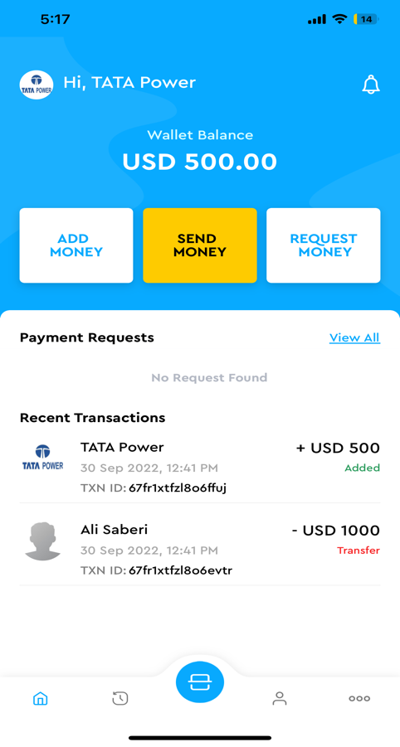

* **Add Money**

You can add money to the wallet from bank debit and credit cards. Card details can be securely stored for future use.

1. Go to Dashboard
2. Click on Add Money button
3. Enter the amount you must add to your wallet
4. Select the card option you want to opt to add money
   1. New card
   2. Saved Card
5. For New Card enter the following details
   1. Name on the card
   2. Card number
   3. Expiry date
   4. CVV
6. For Saved card select the card you want to use to add money
7. Click on Add button

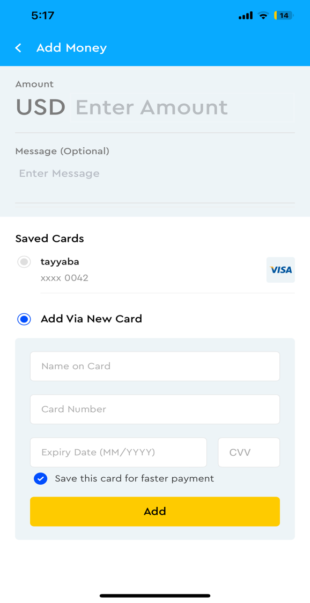

* **Send Money**

You can send money to other users of the Monay wallet.

1. Go to Dashboard
2. Click on Send Money button
3. Select the contact to which you want to send money or click to scan QR code
4. Enter amount
5. Click on Send Money

Users can be searched from the contacts stored or QR code.

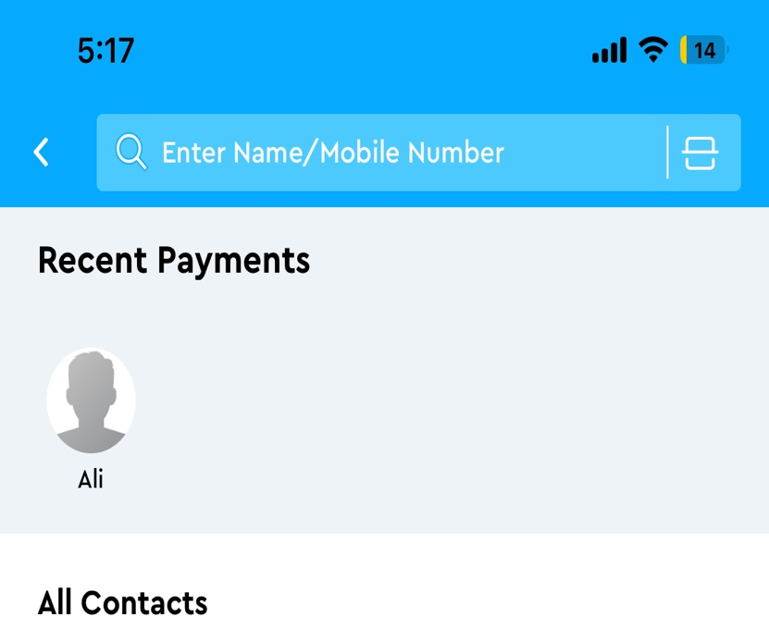

* **Request Money**

You can request money from other users of the Monay wallet.

1. Go to Dashboard
2. Click on the Request Money button
3. Select the contact to which you want to request money or click to scan the QR code
4. Enter amount
5. Click on Request Money

Users can be searched from the contacts stored or QR code.



* **Notifications**

You will receive a notification of sending money and received money in the notifications section

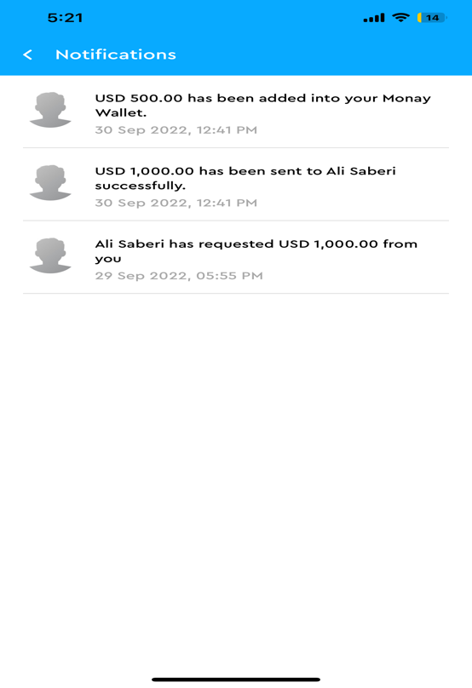

* **My Transactions**

A list of sent and received transactions will be displayed list-wise. Transactions can be filtered by date, name, transaction type, minimum price, and maximum price. Following transactions are possible using the Monay wallet.

* Wallet-to-wallet transfers.
* Withdraw the amount from the wallet to a bank account, UPI ID, or other methods.
* Recharge the wallet using any of the payment modes like UPI, Credit / Debit Card, Bank Account, internet banking, etc.
* Pay-outs:
  + Wallet to any bank account (customer can make purchases at any store/outlet/e-commerce website etc)
  + Wallet to any UPI ID
  + Scan QR (dynamic/static) to pay from your wallet.
* Payment against a Biller’s Payment Request
  1. Direct UPI to a UPI ID against a Payment Request
  2. From Wallet
  3. Against a Debit Card
  4. ISO 2022 Payment using RTP
  5. Go to the My Transactions icon on the Dashboard
  6. You can view a list view of all the transactions
  7. To filter click on the filter icon . A filter dialog box will open
  8. Add data to respective field
  9. Click on Apply filter button

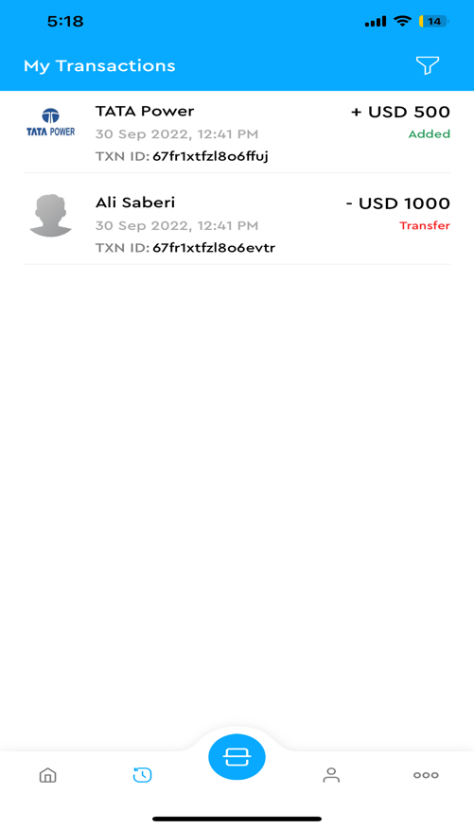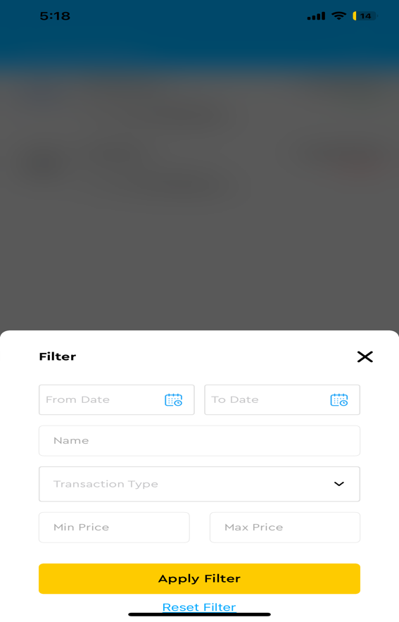

* **QR Pay**

Contactless payment by QR code feature is available in Monay wallet. Users can receive and receive money with a QR code generated by the application. This avoids many of the traditionally associated with electronic payments such as payment cards, payment networks, payment terminals, and merchant accounts.

* + **Pay Money**

Monay wallet allows scanning a QR code from the mobile app. To make a QR code payment, the consumer scans the QR code sent by the other user with their smartphone to pay for their goods They enter the amount they must pay and finally submit.

* 1. Click on the QR code icon on the dashboard
  2. Scan the QR code to pay money
  3. Transaction details will open

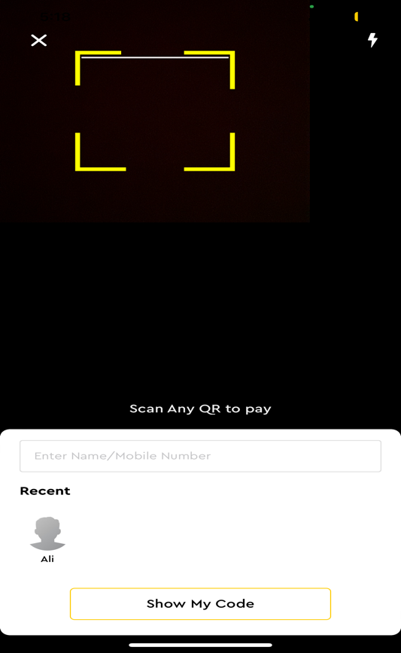

* + **Accept Money**

To accept money QR code can be shared with the users.

* 1. Click on the QR code icon on the dashboard
  2. Click on the Show My Code button
  3. QR Code will open
  4. You can share with your contacts

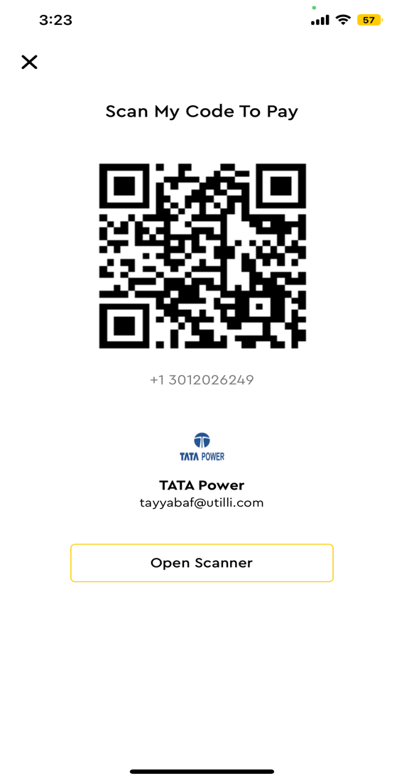

* **More**

To view more Features and settings

* 1. Click on the More icon on the dashboard
  2. More options will be displayed. Select your desirable option

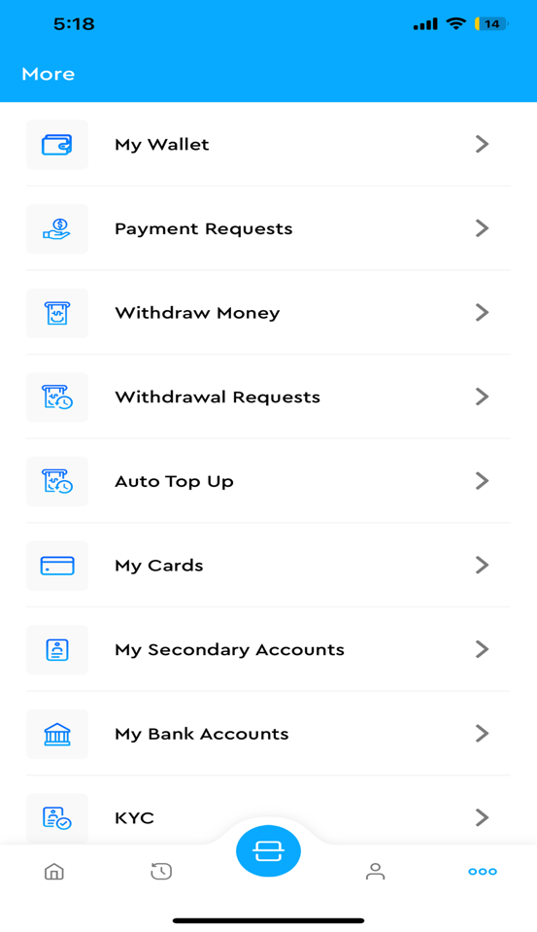

* + **My wallet**

You can view overview of all the transactions of the account in the My wallet section. The available balance, the total of sent money, the total of received money, and the history of all the transactions can be seen in My wallet.

* 1. Click on the More icon on the dashboard
  2. Click on My wallet option

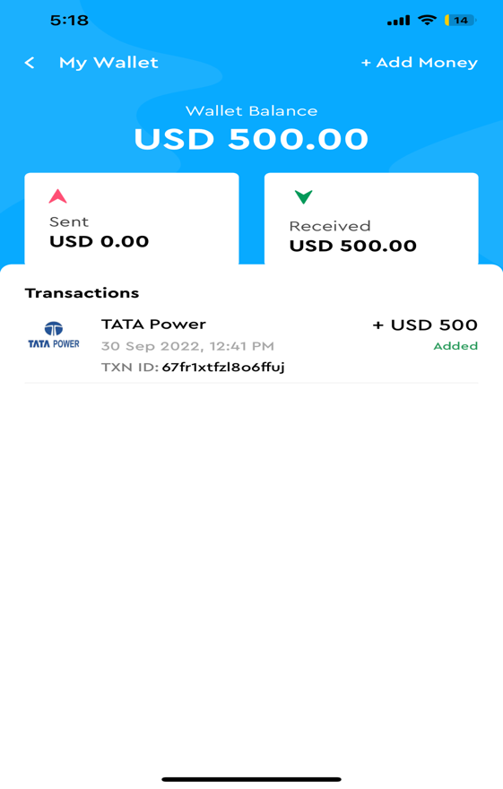

* + **Payment Requests**

You can request another user of Monay wallet to share money. A payment request has the following three statuses:

* + - My request: Pending payment request
    - Received: All the received payment requests are on the account.
    - Paid: Successfully paid payment request
    - Declined: Payment requests that are not paid.

1. Click on the More icon on the dashboard
2. Click on the payment Requests option
3. You can view all payment requests or filtered requests by selecting the desirable tab

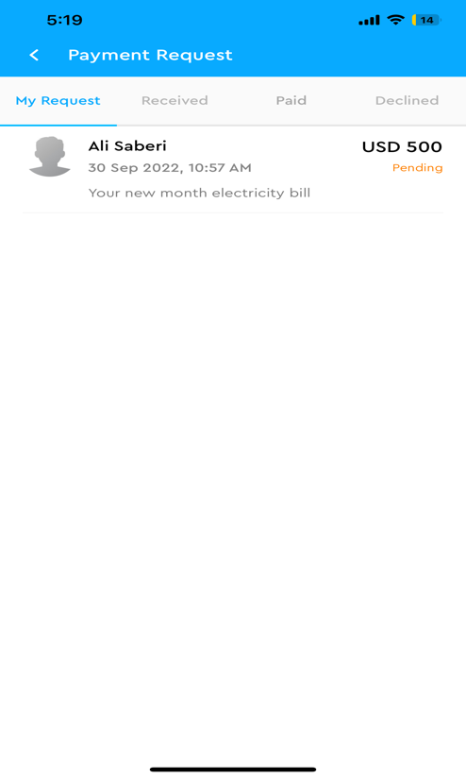

* + **Withdraw Money**

You can withdraw the available balance from the Monay wallet to a bank account. Amount to withdraw and bank details are required to withdraw money.

1. Click on the More icon on the dashboard
2. Click on the Withdraw Money option
3. You can view your wallet balance
4. Enter the amount to withdraw
5. Select the account to transfer withdrawn money
6. Click on the send request button

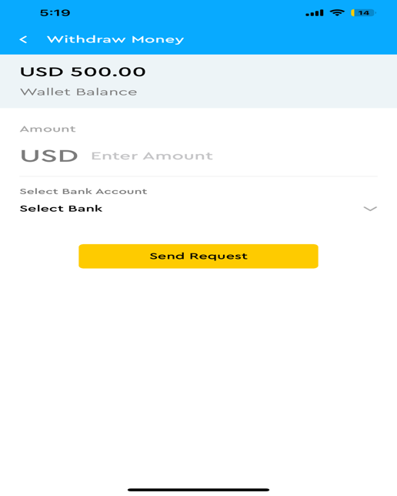

* + **Withdrawal Requests**

1. Click on the More icon on the dashboard
2. Click on the Withdrawal Requests option
3. You can view your requests

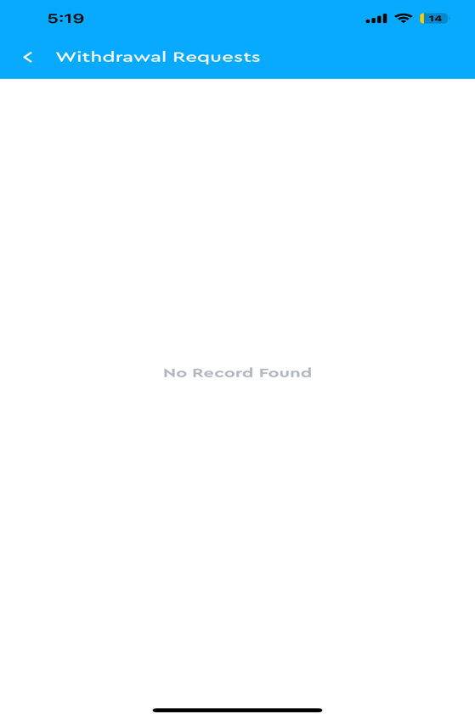

* + **Auto Top up**

Wallet balance can be automatically recharged of a certain amount when it reached a specified minimum amount. You will specify the minimum amount on which auto pop-up will occur, the amount to be recharged, and card details from which the amount will be transferred to Monay wallet.

1. Click on the More icon on the dashboard
2. Click on the Auto Top-up option
3. Enter a minimum amount on which auto top-up will occur
4. Enter the amount to refill on auto top up
5. Select the card to recharge the amount

Only cards that do not require CVV on every transaction can be used. The auto top-up feature can be enabled or disabled at any time.

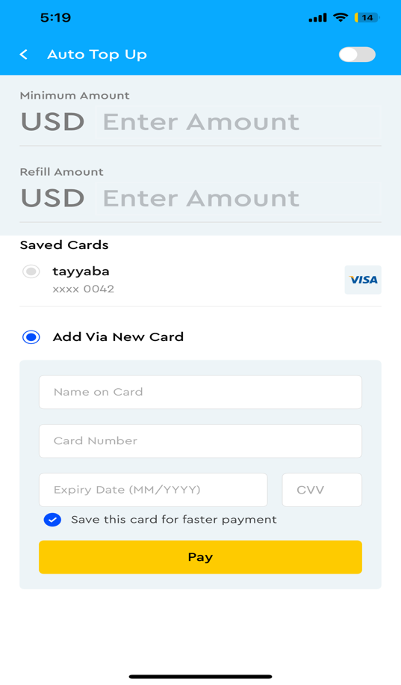

* + **My Cards**

Monay wallet can be linked to the card to recharge your balance or withdraw money to the bank account. You can securely save your cards for future use

1. Click on the More icon on the dashboard
2. Click on My Cards
3. To add a new card, click on Add new card button on the top of the screen

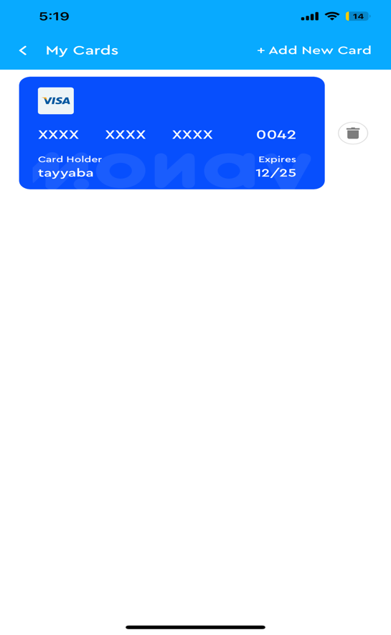

* + **My Secondary Accounts**
  + **My Bank Accounts**

You can link your Monay wallet to your bank account to recharge the balance or withdraw money to the bank account.

All the bank details for the purpose will be securely stored.

1. Click on the More icon on the dashboard
2. Click on My Bank Accounts
3. Enter the account holder’s name
4. Enter Bank name
5. Enter bank account number
6. Enter Routing number
7. Enter swift code
8. Click on save details button

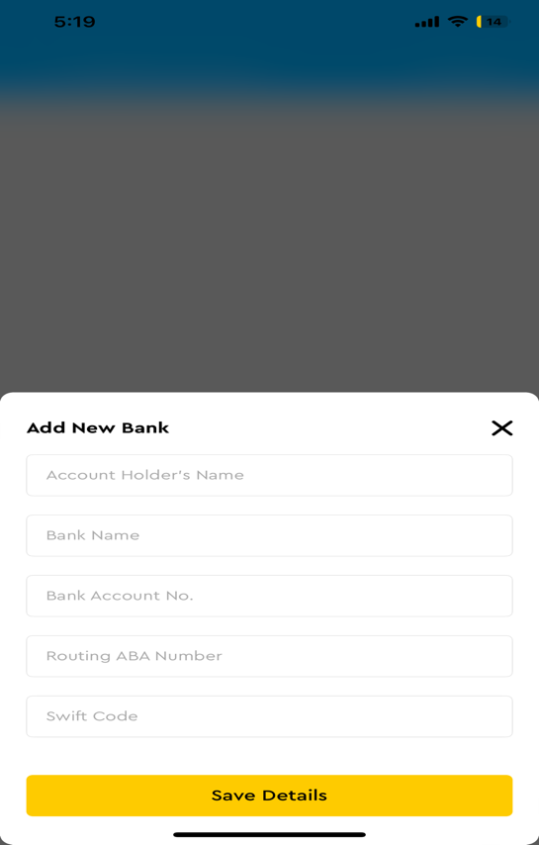

* + **KYC**

Know your customer is the process to verify the user details. KYC details will update according to the country selected.

* + - **Full KYC**

All the details are required for the merchant account.

* + - **KYC Lite**

Minimum fields are required for primary accounts.

1. Click on the More icon on the dashboard
2. Click on KYC option
3. Enter your KYC details
   * **Share and Invite**

You can add a secondary account user by scanning the QR code or clicking on the invite link.

1. Click on the More icon on the dashboard
2. Click on Share and Invite option
3. Share QR code
4. To share the Payment link, click on Share Invite link button

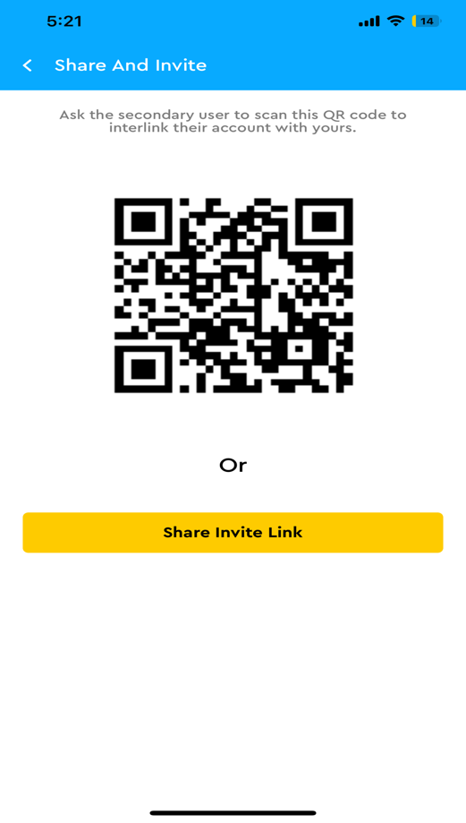

* + **Settings and support**

You can configure and customize the settings, configure payment methods, and manage notifications.

1. Click on the More icon on the dashboard
2. Click on Settings and support option

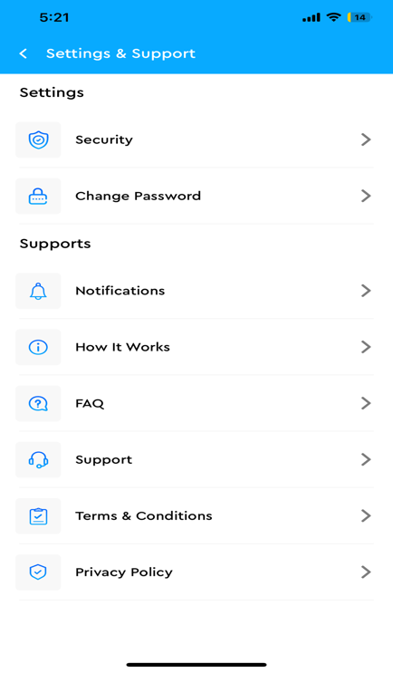

* + **Security**

For secure login and transaction, a 4-digit PIN is set up that will be required on every transaction. Moreover, to make application login secure Face ID, Fingerprint and PIN can be set up.

1. Click on the More icon on the dashboard
2. Click on the Security option
3. To set 4-digit PIN click on “Use Monay PIN”
4. You can also enable App Lock security by toggle button.

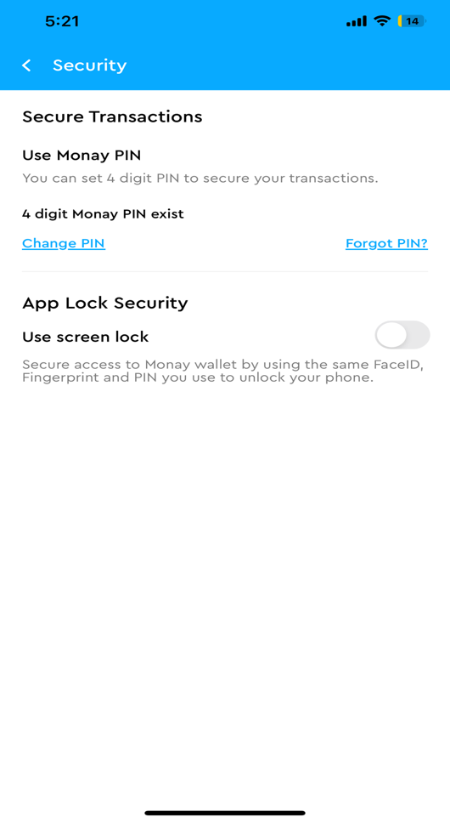

* + **Change Password**

Password can be reset from the change password tab.

1. Click on the More icon on the dashboard
2. Click on the Change Password option
3. Enter Current Password
4. Enter new password
5. Re-enter the new password
6. Click on Update button

